Introducing Innovation!

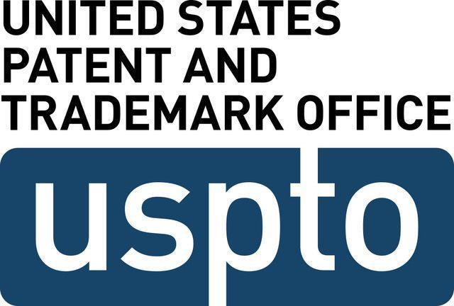
Have you ever thought to yourself, “This would be better, if only…”? Thoughts like this have led to inventions that now make our lives easier and better, from the microwave to prosthetic limbs. Turning ideas into inventions has helped humans to survive and our world to evolve. Think about it, would the world be the same without the wheel, the light bulb, or the telephone?
An invention is a new useful product or method that did not exist previously and was created by the mind or imagination. In the 1870’s, when people wanted to talk to a friend, they would either need to send them a message in writing, or go over to their house and see them. People wanted an option to talk to hold conversations without being in the same room. That wasn’t possible until the telephone was invented. When people have needs and wants that push the bounds of existing technology, innovation happens and inventions are created.
The United States Patent and Trademark Office (USPTO) is the federal agency responsible for the issuance of U.S. patents and trademarks to keep track of new inventions.
A patent is a property right granted by the government to an inventor for a new, useful, and non-obvious invention. Patents describe an invention with words and drawings. Patents allow inventors to prevent others from making, using, or selling their inventions without permission for a limited time. Patents are novel, useful, and non-obvious
- Novel means that the invention is different from all other inventions
- Useful means that the invention works and has a purpose
- Non-obvious means that the invention is different enough from all other inventions that it would take more than common sense to combine ideas to make the invention.
A trademark can be anything that can identify, distinguish, and indicate the source of a product or service and distinguish that source from other sources. Symbols, words, designs, scents, and even colors can function as trademarks so long as they are capable of identifying and distinguishing a source.
Think of some of your favorite objects. Why might someone have invented them?

Object | Reason for inventing
Example: Telephone | To communicate with friends without seeing them or writing them a note
After thinking about inventions, innovation, patents, and trademarks, answer the following questions

1. Why do people invent?

2. Why are patents important?

3. Why are trademarks important?

4. If you could invent something that was novel, useful, and non-obvious, what need or want would you address? (Example: People want to get places faster, so I would invent rocket shoes.)

5. What is your favorite invention in the world? Why?

