Offline Activity Adaptation:
Holland Codes and Ocean Careers with

Let’s explore Ocean Careers with the team of the Nautilus! Below, ten different categories of ocean careers are highlighted, as well as a spotlight interview with a member of the Nautilus team in each career category.
- For each category, assign up to 3 Holland Codes that you feel best match the career and explain your reasoning in the boxes under each Ocean Career.
- Which career best matches your Holland Codes? ______________________________________
- Would you be interested in this career? Why or Why not?

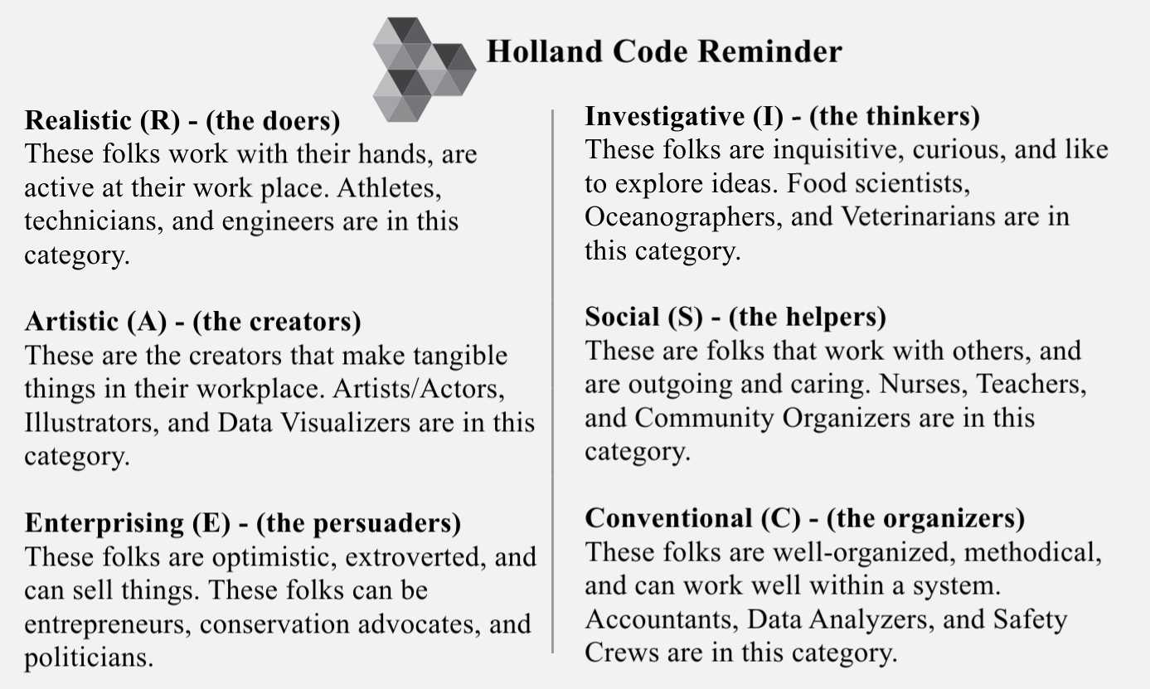
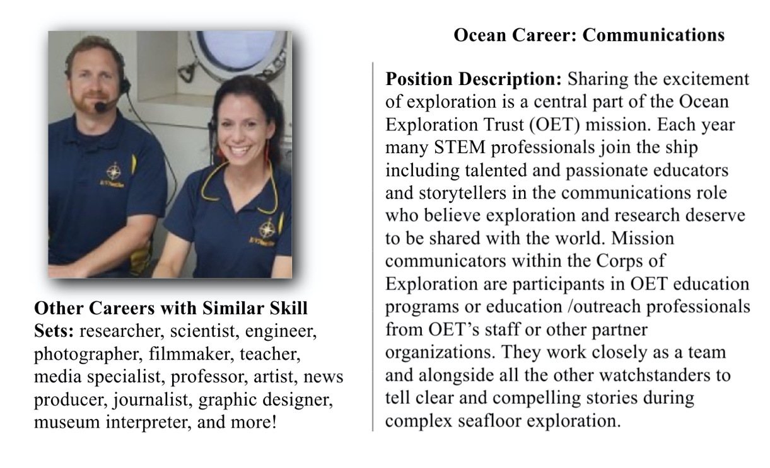
Holland Code(s):

Why did you assign that/those Holland Codes?

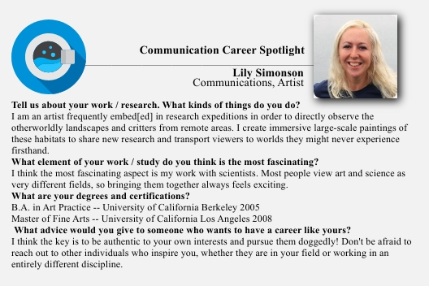

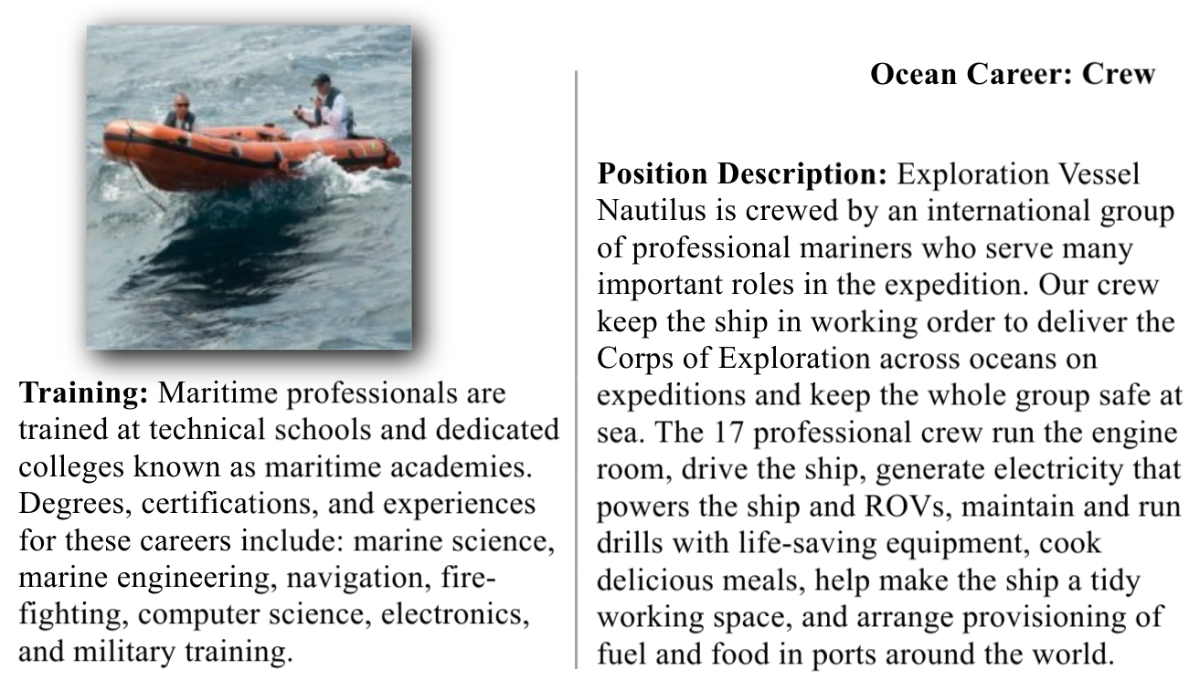
Holland Code(s):

Why did you assign that/those Holland Codes:

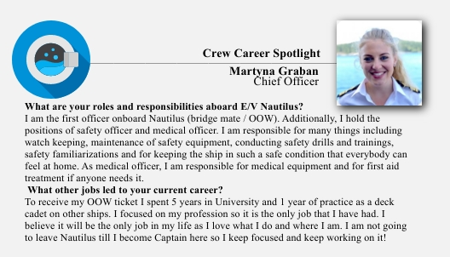
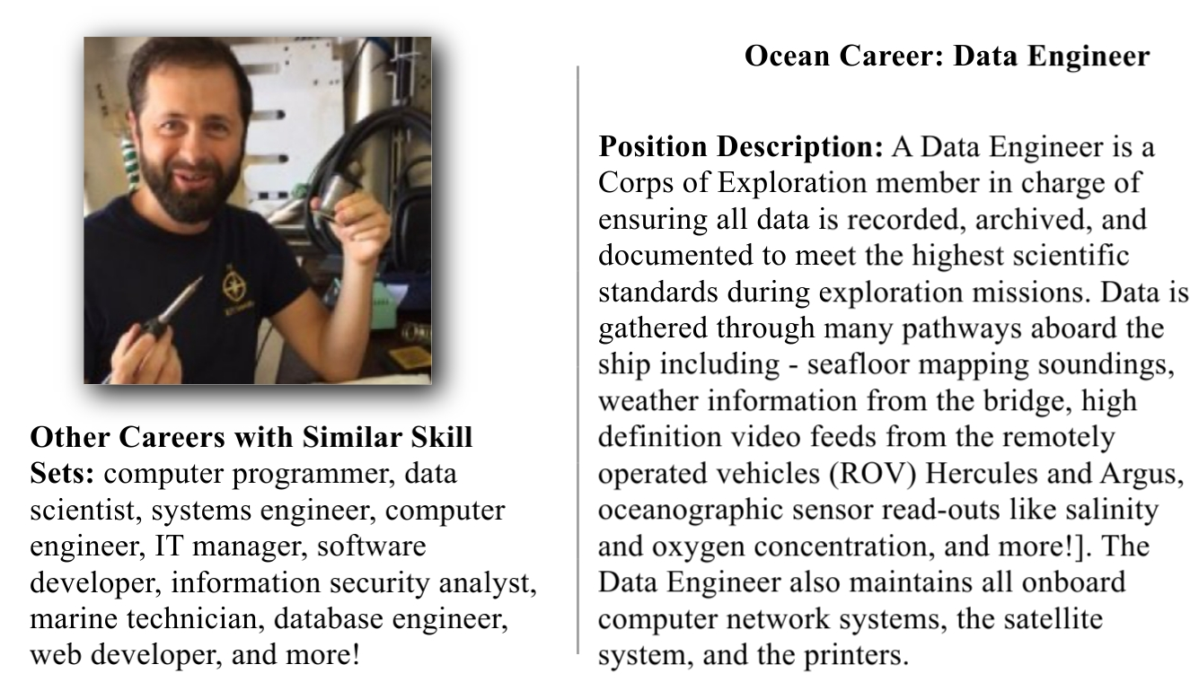
Holland Code(s):

Why did you assign that/those Holland Codes?

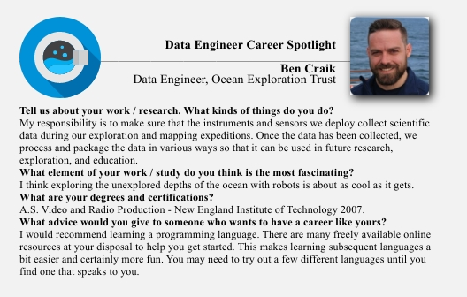

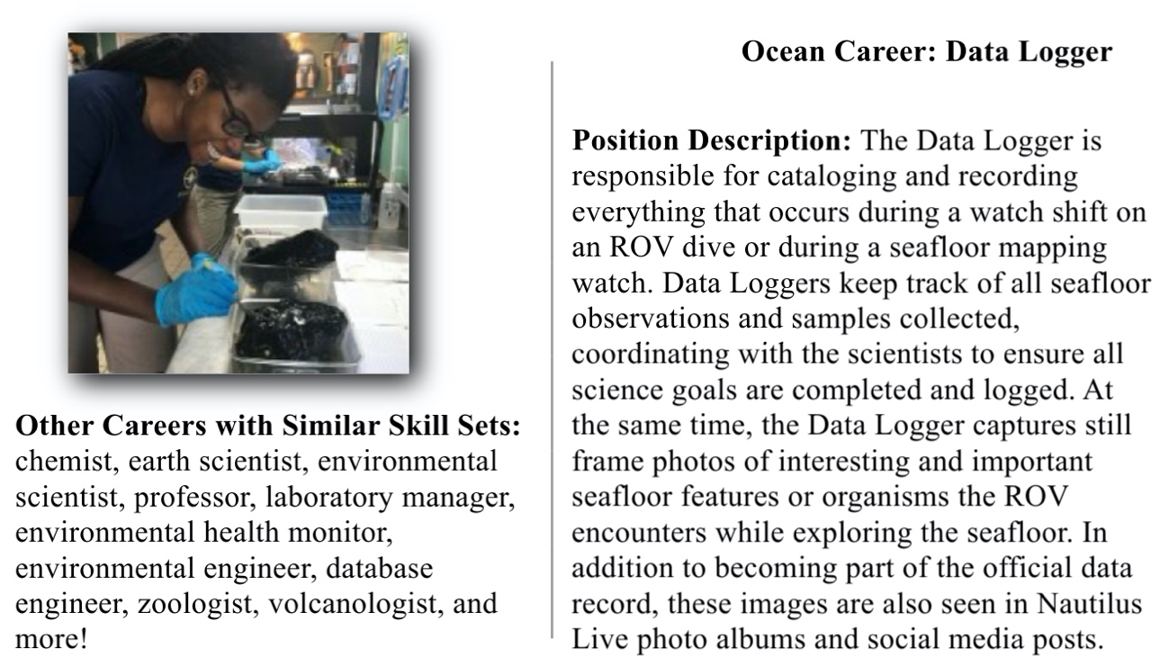
Holland Code(s):

Why did you assign that/those Holland Codes?

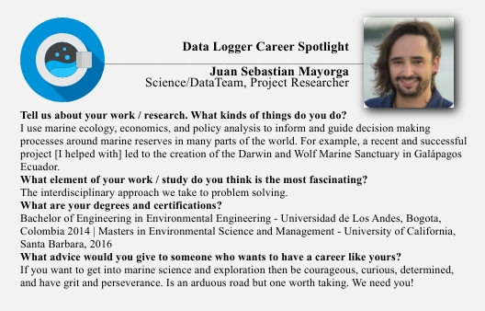
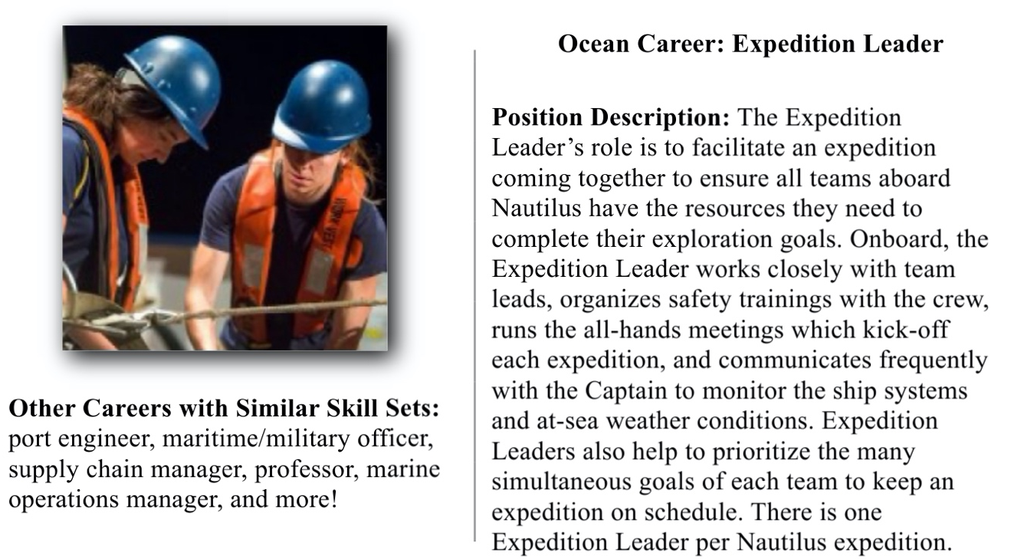
Holland Code(s):

Why did you assign that/those Holland Codes?

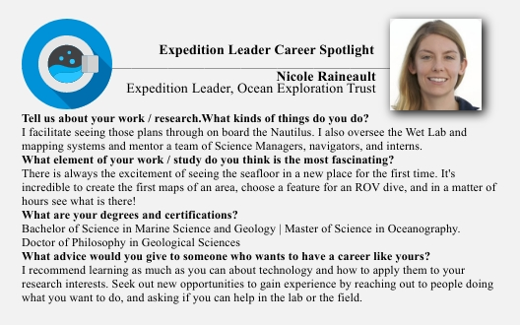
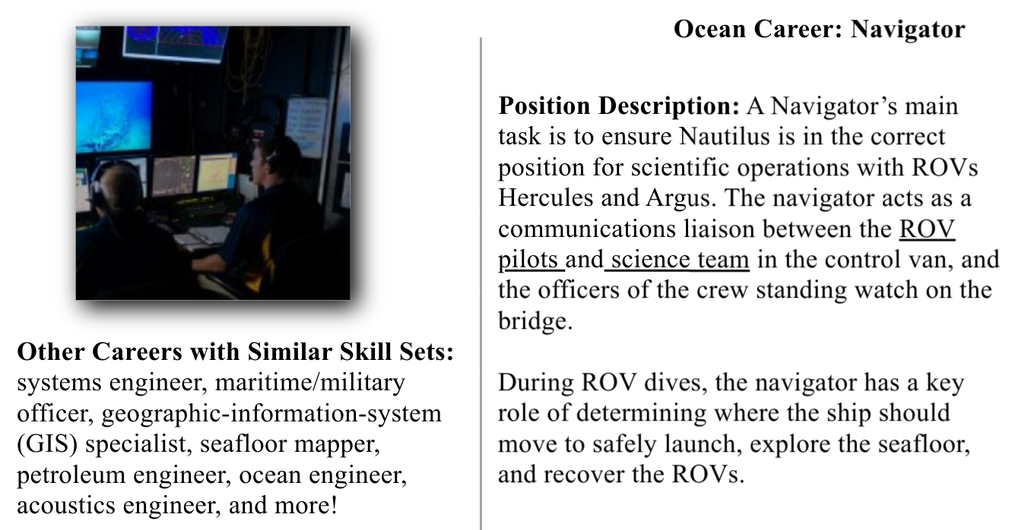
Holland Code(s):

Why did you assign that/those Holland Codes?

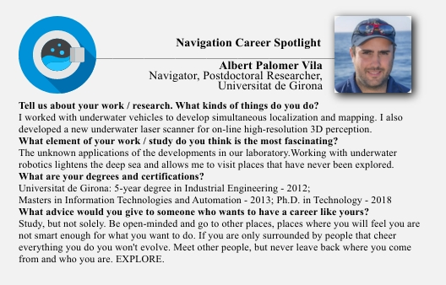
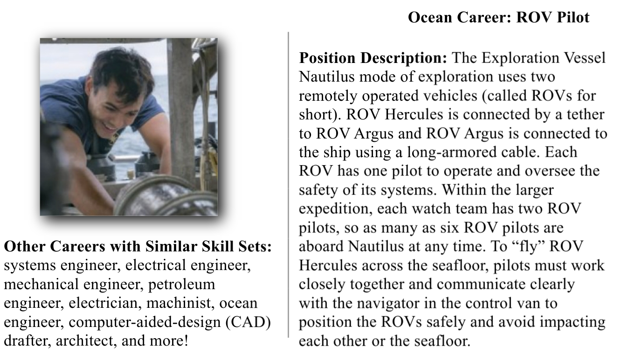
Holland Code(s):

Why did you assign that/those Holland Codes?

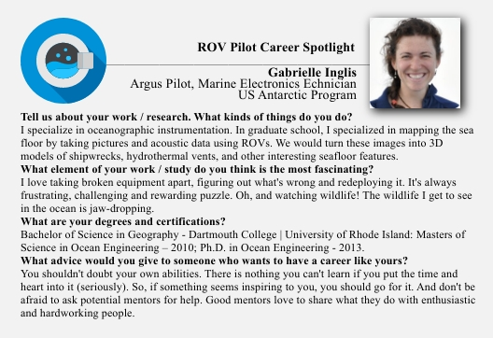
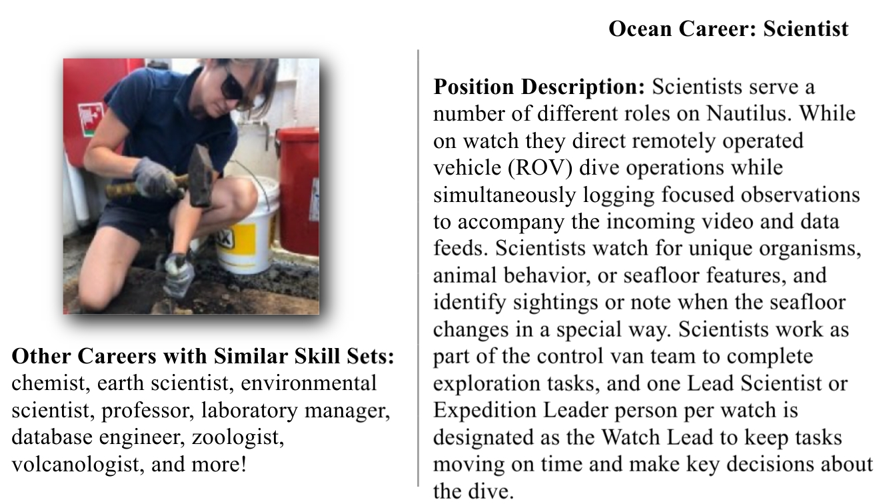
Holland Code(s):

Why did you assign that/those Holland Codes?

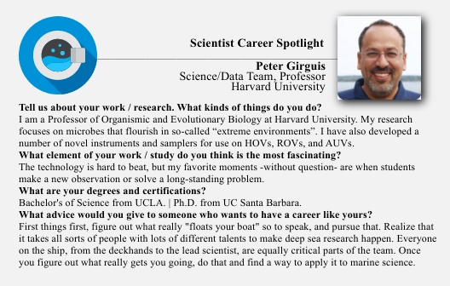
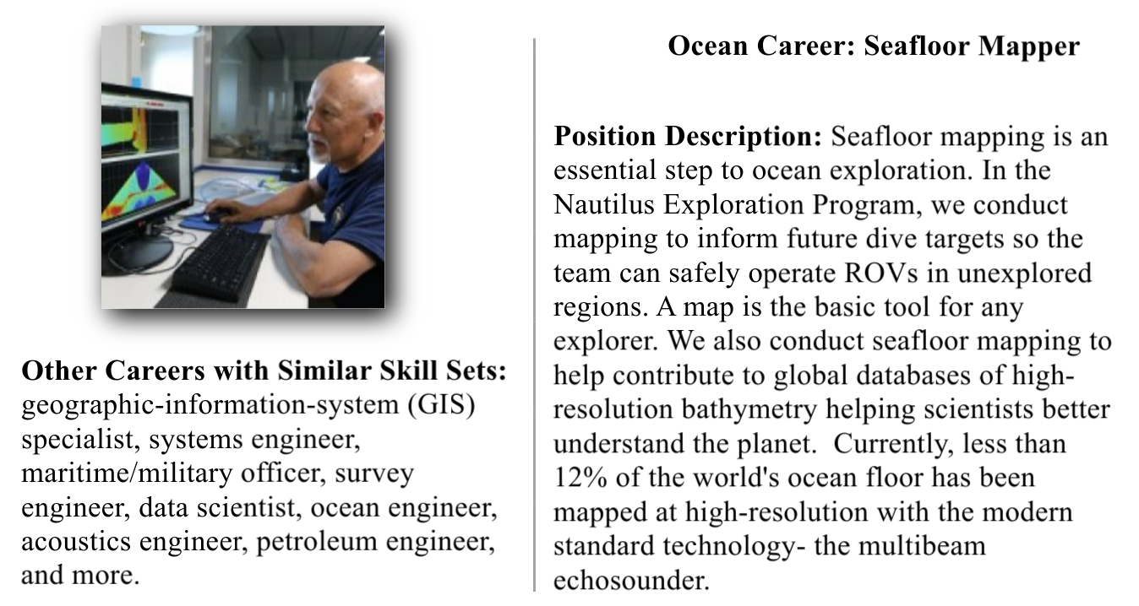
Holland Code(s):

Why did you assign that/those Holland Codes?

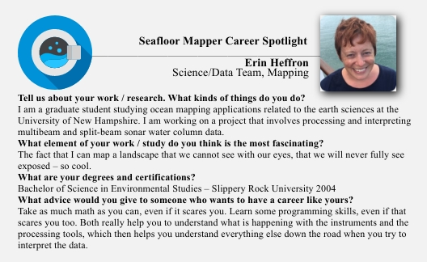
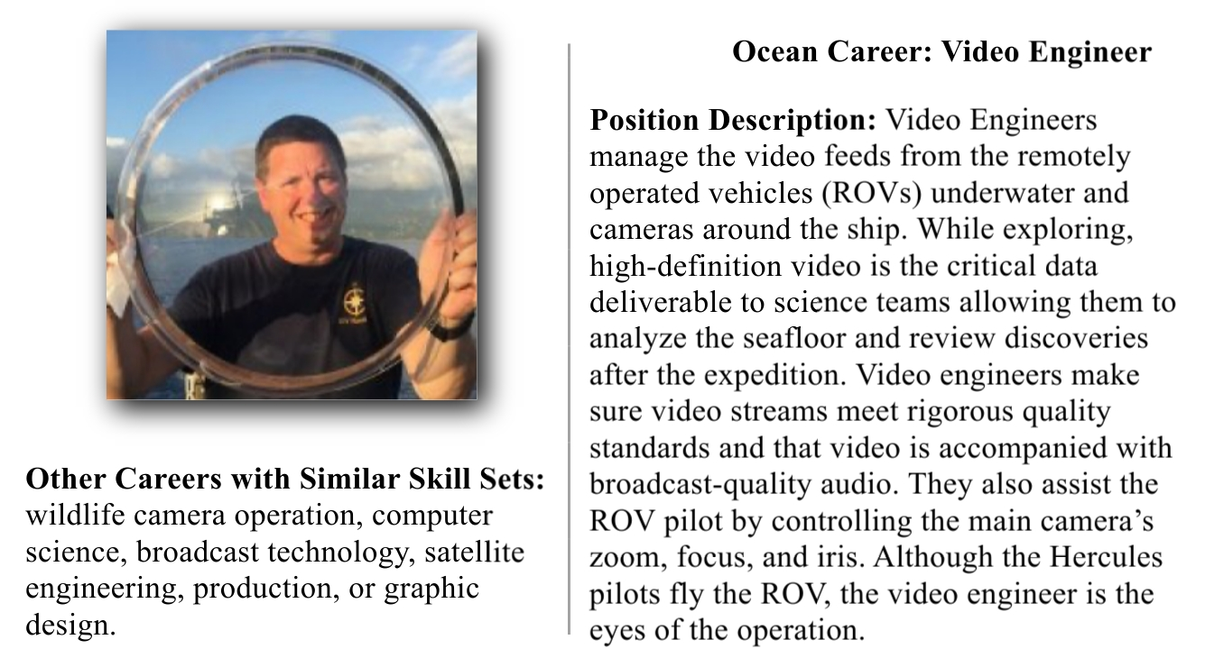
Holland Code(s):

Why did you assign that/those Holland Codes?

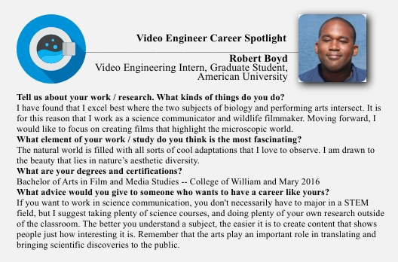

To find more information about who works on the Nautilus, meet the team on their website: https://nautiluslive.org/people.

Interview information was pulled from the Nautilus Live page on 4/18/2020 to create an offline supplement to the lesson: Ocean Careers and Holland Games created by Oregon State University’s SMILE program and the Regional Class Research Vessel (RCRV).

