## OSU_COE_horizontal_2C_O_over_B.eps

Gone Fishin’ – Student Worksheet

**Your Name:** \_\_\_\_\_\_\_\_\_\_\_\_\_\_\_\_\_\_\_

**Team Member Names:** \_\_\_\_\_\_\_\_\_\_\_\_\_\_\_\_\_\_\_\_\_\_\_\_\_\_\_\_\_\_\_\_\_\_\_\_\_\_\_\_\_\_\_\_\_\_\_\_\_\_\_\_\_\_\_\_\_\_\_\_\_\_\_\_\_\_\_\_\_\_\_\_\_\_\_\_\_\_\_\_\_\_\_\_\_\_\_\_\_\_\_\_\_\_\_\_\_\_\_\_\_\_\_\_\_\_\_\_\_\_\_\_\_\_\_\_\_\_\_\_\_\_\_\_\_\_\_\_\_\_\_\_\_\_\_\_\_\_\_\_\_\_\_\_\_\_\_\_\_\_\_\_\_\_

**Team Name:** \_\_\_\_\_\_\_\_\_\_\_\_\_\_\_\_\_\_\_

**Introduction:**

Congratulations! You and your team are the proud brand-new owners of a small fishing company! Your goal as a fishing company is to try to catch the most fish over the next few years to earn the most money.

# Part 1 – Run the Game

**Order Example**

**Round rules:**

Team Number

15

* 1 round = 1 year.
* [1 min] Determine # of fish to catch.
* Orders filled randomly.
* Order too much? No catch!
* Keep track in table on the back

Number of Fish

**Fish regeneration rules:**

* Population doubles at end of every year…
  + BUT it’s capped at 50.

*Discuss your team’s strategy for catching fish and write down your approach here:*

**Score Keeping Table:**

|  |  |  |  |
| --- | --- | --- | --- |
| **Round Number** | **Fish Ordered** | **Fish Caught** | **Notes on the round** |
| 1 |  |  |  |
| 2 |  |  |  |
| 3 |  |  |  |
| 4 |  |  |  |
| 5 |  |  |  |
| 6 |  |  |  |
| 7 |  |  |  |
| 8 |  |  |  |
| **Total Fish Caught** | |  |  |

# Part 2 – Debrief

Answer the following questions individually, then share with your team after a few minutes:

*What happened to the fish population over time?*

*How did orders change over time? Why?*

***(2.2a)***

**Your Name:** \_\_\_\_\_\_\_\_\_\_\_\_\_\_\_\_\_\_\_

**Model a Classroom System**

Work by yourself, in pairs, or as a team to model interactions within this system.

*Draw lines between parts to show relationships. Label these relationships like the examples from the presentation. How did one thing affect another? You can also add additional parts that you think would help model the system better.*

**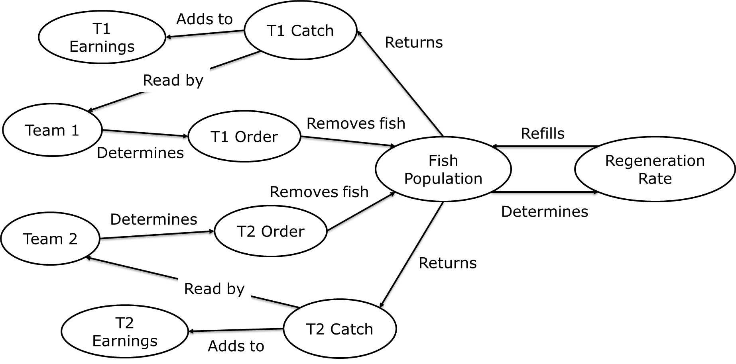**

**How can we improve the system?**

Here are questions to think of for this part:

* *What elements would you add/change/remove?*
* *What relationships would you add/change/remove?*

**Challenge:** Draw the changes you would make in the diagram!

***(2.2b)***

**Your Name:** \_\_\_\_\_\_\_\_\_\_\_\_\_\_\_\_\_\_\_

**Model the System**

Work by yourself, in pairs, or as a team to model interactions within the system.

*Draw lines between parts to show relationships. Label these relationships like the examples from the presentation. How did one thing affect another? You can also add additional parts that you think would help model the system better.*

**How can we improve the system?**

Here are questions to think of for this part:

* *What elements may be added?*
* *What relationships might you add/change/remove?*

# Part 3 – (Optional) Run the Game Again

**Score Keeping Table:**

|  |  |  |  |
| --- | --- | --- | --- |
| **Round Number** | **Fish Ordered** | **Fish Caught** | **Notes on the round** |
| 1 |  |  |  |
| 2 |  |  |  |
| 3 |  |  |  |
| 4 |  |  |  |
| 5 |  |  |  |
| 6 |  |  |  |
| 7 |  |  |  |
| 8 |  |  |  |
| **Total Fish Caught** | |  |  |

# Part 4 – Tragedy of the Commons

**Your Name:** \_\_\_\_\_\_\_\_\_\_\_\_\_\_\_\_\_\_

Our game provided an example of the Tragedy of the Commons archetype. This is when a shared resource is used selfishly by a bunch of individuals without considering the public good, which eventually leads the spoiling the resource for everyone.

Work individually or with your team to identify the parts of the common scenarios below. Maybe you can even find one or two scenarios yourself!

|  |  |  |  |  |
| --- | --- | --- | --- | --- |
| **Scenario** | **Shared Resource** | **Users** | **What happens in this situation?** | **What are potential fixes?** |
| Overfishing | Fish | Fishing Companies | Individuals try to catch as much fish as they can for themselves without considering others’ needs or the fish regeneration rate. This collapses the fish population. | Create a central government body that limits the fish catch; educate the companies so they understand how much they can take. |
| Crowded Swimming Pools |  |  |  |  |
| Traffic Congestion |  |  |  |  |
| Groundwater Usage |  |  |  |  |
| Earth’s Atmosphere |  |  |  |  |
|  |  |  |  |  |