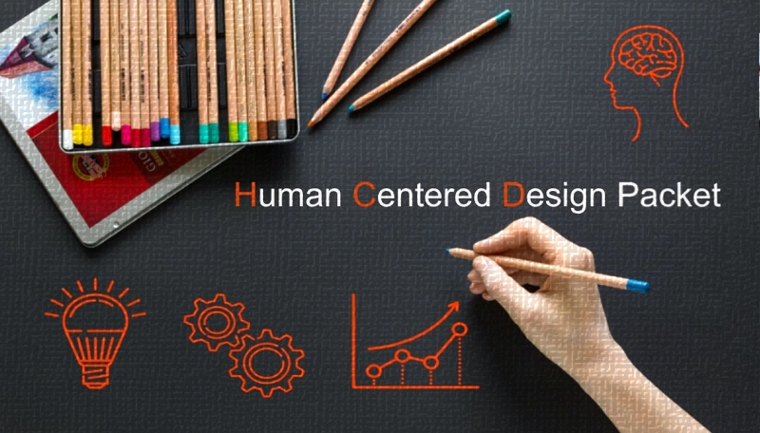
This Human Centered Design (HCD) Packet is used in our Precollege Programs’ virtual lesson for educators “Human Centered Design – Masks and Backpacks.”

The Packet can be applied to anything YOU decide to create!

What type of product are you creating/improving?
Use this space to jot down some quick ideas about your product. It may help to include a basic image.
Notes: | Sketch:
Who will use your product and what do they care about?
Connecting with your users!

Some ways to get inside the mind of your user are: interviews, observations, and research. You should also come up with a plan to incorporate user feedback throughout the design process when possible.

Who will use your product (age range, purpose, etc.)? | What is important to your user(s)?

Understanding the problem and solutions from the user’s perspective!
What problem are you trying to solve with your product? How will you know when you have solved it? It can be useful to create a list of criteria for the design and rank the user’s wants/needs.

What problem will your product address?

What does your user need/want from the product (e.g. materials, functionality, etc.)?

How will you know when you have been successful?

Considering radical ways to design a solution (product)!
How can you think about your solution (product) differently? How creative can you be with your product version? Some ways to help with the creative process are: brain spins, brainstorming, and SCAMPER (see below).
Substitute – Replace a thing, or concept, with something else
Combine – Unite! What? Who? Ideas? Materials?
Adapt – Adjust to a new purpose. Reshape? Tune-up?
Modify, Magnify, Minify – Change the color, materials, size, shape, etc.
Put to another use – Change when, where, location, time, or how to use it.
Eliminate – Omit, get rid of, cut out, simplify, weed out, etc.
Rearrange, Reverse – Change the order of things, including the plan.

Applying Science, Technology, Engineering, and Math to invent something tangible, and then engaging in redesign to create an optimal solution.

How do you know this is the optimal product for your user?
Fail fast, learn fast: Start creating and revising prototypes as soon as possible. The goal is to improve upon your previous design in order to make your product the best it can be!
*Remember to keep your user’s wants/needs in mind!

Showing how the solution meets the needs of the user and marketing the invention!
How did your test run go? Did someone else try it out? How did they like it?
It may be useful to keep track of a few things: what aspects of your product did you test, how did you test your product, any quick improvements. This is also the time to come up with a marketing pitch, a video, message, logo and anything else to help market your product.

Any notes from your test-run? What went right/wrong?

How will you market your product (e.g. create empathy, make it fun)?

What were your user’s thoughts about the product?

To find the complete virtual lesson “Human Centered Design – Masks and Backpacks” and other lessons visit our Precollege Programs virtual professional development page.

https://precollege.oregonstate.edu/virtual-professional-development-teachers.

