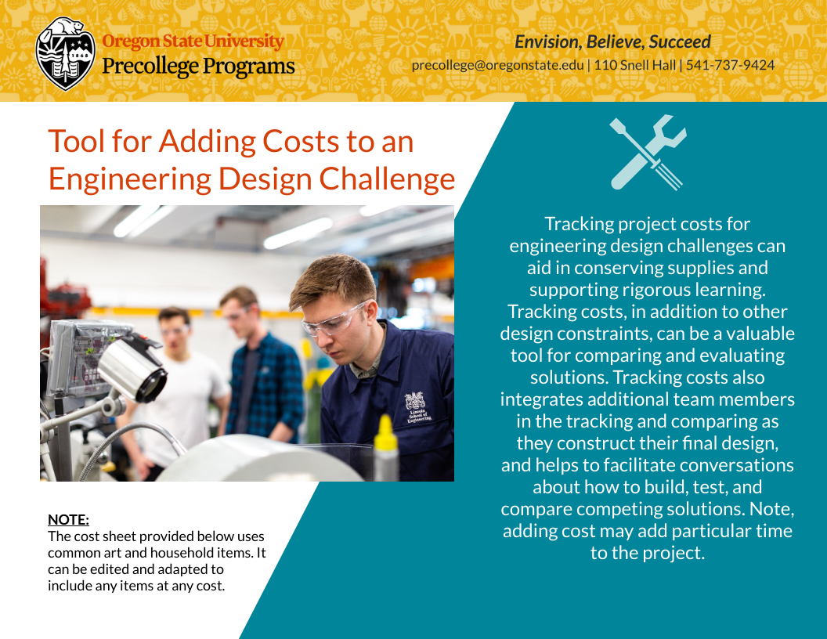
Cost Sheet
(Trial 1)

Budget: $100,000

TRIAL 1
Order Form Trial 1 (15 mins)
Material | Cost | Quantity
Aluminum Foil (1 foot) | $30,000
Tape (1-foot strip) | $20,000
Big cup | $25,000
Small Cup | $20,000
Straw (x2) | $10,000
Popsicle Sticks (x2) | $10,000
Pipe Cleaners | $5,000
Cork | $5,000

Returns Total:
Material | Cost | New total

Cost Sheet
(Trial 2)

Leftover Budget from Trial 1: $__,000

TRIAL 2
Order Form Trial 2 (10 mins)
Material | Cost | Quantity
Aluminum Foil (1 foot) | $30,000
Tape (1 foot strip) | $20,000
Big Cup | $25,000
Small Cup | $20,000
Straw (x2) | $10,000
Popsicle Sticks (x2) | $10,000
Pipe Cleaners | $5,000
Cork | $5,000
Total:

Final Design
(draw an arrow to each component one for each team member)
Team members:
_______________________________________________________________________________
_______________________________________________________________________________
_______________________________________________________________________________

Instructor Checkpoint: ____________________

