How Submarines Work
LaCuKnoS Language Booster

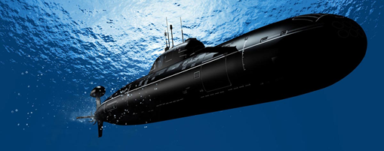
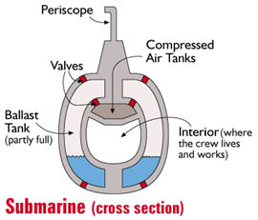
People have always wanted to fly like birds, and eventually we invented airplanes. Similarly, people have wished to swim underwater like fishes, and so we invented submarines. Designs for underwater boats or submarines were developed in the 1500s. However, it was not until the 1800s that the first useful submarines were made and tested.

A submarine (or any boat) can float when the mass of water that it displaces (pushes out of the way) is equal to the mass of the boat. This displaced water causes an upward force called buoyancy. Buoyancy acts in the opposite direction to gravity, which would pull the ship down. A regular boat cannot control or change its buoyancy, but a submarine can. This allows a submarine to dive under the water or to come up to the surface.

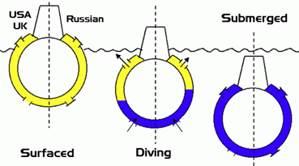
To control its buoyancy, the submarine has ballast tanks (see picture) that can be filled with water or filled with air. When the submarine is on the surface, the ballast tanks are filled with air. This makes the submarine's density less than the density of the water. When the submarine dives, water is pumped into the ballast tanks to replace the air. This makes the density of the submarine greater than the density of the water and the submarine sinks. Tanks of compressed air are kept on the submarine and when the crew wants to go back to the surface, they pump air into the ballast tanks to force out the water.

Talk with your partner about these questions, then write your answers.

- Use your own words to describe what causes a submarine to dive under the water and what causes it to rise back to the surface.

2. List some objects that you have seen float or sink. What do they have in common? Why do you think they float or sink? What do you think affects their buoyancy?

Cartesian Diver
LaCuKnoS Science Investigation

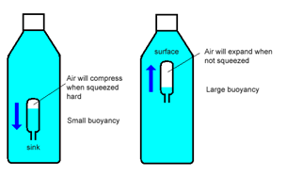
The Cartesian diver is named after the French philosopher, mathematician and scientist René Descartes, but Descartes did not invent the Cartesian diver. It was invented by a student of Galileo's named Raffaelo Maggiotti, who was looking for an easy way to teach people about why objects sink and float. A Cartesian diver and a submarine work in similar ways. In this investigation, you will make a Cartesian diver and examine how the diver in the bottle works like a submarine that dives below the water and then rises back up to the surface. You will observe how changing the pressure and the volume of the bottle influences the sinking and floating of the Cartesian diver. The Cartesian diver is a model that can help you explain your understanding of buoyancy and how submarines dive down and then come back to the surface of the water.
Materials:

- Plastic Pipette or dropper
- Metal nut
- Food coloring (dark color)
- Modeling clay
- Scissors
- Clear plastic cup
- Clear plastic bottle with no labels (16 oz, 20 oz, 1 liter or 2 liter)
- Water

Procedure:
1. Slide the metal nut onto the end of the plastic pipette. If necessary, secure the nut with a small piece of clay to help it stay in place.
2. Use scissors to cut the tube off the plastic pipette below the nut, leaving about 1 centimeter sticking out. This is your Cartesian diver.
3. Fill the plastic cup about half way with water.
4. Add enough food coloring to the water in the cup so that the water looks dark.
5. Place the Cartesian diver into the cup of water.

Does it sink or float? Why?

6. Add water to the Cartesian diver by squeezing and releasing it in the cup until the diver barely floats in the cup. You may have to add or remove small amounts of water until the Cartesian diver barely floats.
7. Fill the clear plastic bottle with clear water until it is completely full.
8. Move the Cartesian diver from the cup to the bottle. Make sure that the diver is floating in the bottle (if it sinks, remove it and start again)..
9. If needed, add more water to the bottle until it is filled to the top.
10. Screw the cap on the bottle, closing it tightly.
11. Squeeze the bottle firmly and hold the squeeze. Observe what happens to the Cartesian diver.
12. Stop squeezing the bottle and observe what happens. Repeat.
13. What are your observations of what happens to the Cartesian diver when you squeeze and when you release the bottle? Draw and write your observations in the chart below.

Squeezed Bottle | Unsqueezed/Released Bottle

With your partner, discuss and then write an answer to the following questions.
1. What happens when the bottle is squeezed?

2. What happens when the bottle is released (unsqueezed)?

3. How is this similar to what happens in a submarine when it dives and comes back up to the surface?

Cartesian Diver
LaCuKnoS Lab Notes
Practice: Using Models to Explain Cause & Effect Relationships
Describe one of the Effects that your Cartesian diver model helped you to observe. | Describe the Cause(s) of the Effect that you described.

How would you explain this cause and effect relationship to a 3rd grader in language that they would understand?

How would you explain this cause and effect relationship to your science teacher in language that they would use?

Cartesian Diver
LISELL-B Concept Cards

Buoyancy/Flotabilidad
A natural phenomenon force that pulls an object
La capacidad o tendencia a flotar en el agua o el aire o algún otro fluido
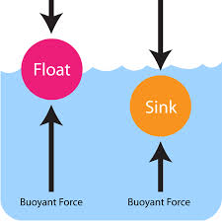
Concept Card

Density/Densidad
A measure of how much matter is in a certain volume.
Una medida de cuánto materia está en cierto volumen.
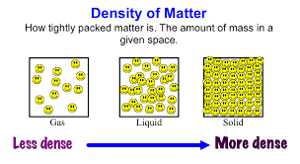
Concept Card

Volume/Volumen
The amount of space inside an object or the amount of space that an object uses
La cantidad de espacio dentro de un objeto o la cantidad de espacio que utiliza un objeto
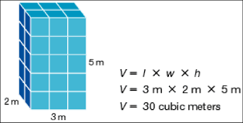
Concept Card

Mass/Masa
A measure of how much material is in an object, commonly measured by how much something weighs.

Una medida de cuánto material hay en un objeto, comúnmente medido por cuánto pesa algo
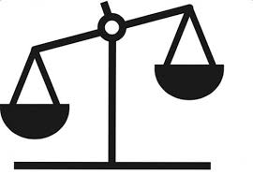
Concept Card

